
DEPARTMENT OF ARTIFICIAL INTELLIGENCE AND MACHINE LEARNING

PROBLEM SOLVING -I GROUP 2
(USN ending with 1, 6, 8)

Course: Computer Architecture Course code: 25AIM34
Sem / Sec: III E Max. Marks: 15
Release Date:22/10/2026 Due Date:29/10/2026
1. Develop a Python program to perform signed binary arithmetic using the 8-bit 2’s complement representation. Use the program to verify the results of the following arithmetic expressions:
a) (25 + (+18))
b) ((-25) + (-18))
For each expression, display the operands in 8-bit 2’s complement binary format, perform the binary arithmetic operation, and display the final result in both binary and decimal formats. Verify the program output against the results obtained through manual binary calculations and identify any arithmetic overflow.
Program
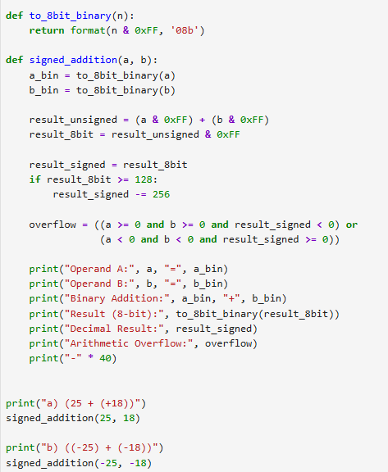
Output
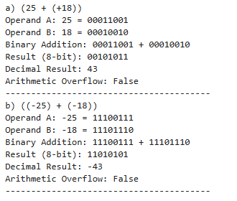

manual binary calculation
a)25+(+18)
00011001 (+25)
+ 00010010 (+18)
---------------
00101011
${\left(00101011\right)}_{2}=32+8+2+1=43$

Decimal verification: ${\left(25\right)}_{10}+{\left(18\right)}_{10}={\left(43\right)}_{10}$.

b) (-25)+(-18)
+25 = 00011001; invert and add 1 to get -25 =${\left(11100111\right)}_{2}$.
+18 = 00010010; invert and add 1 to get -18 =${\left(11101110\right)}_{2}$.

11100111 (-25)
+ 11101110 (-18)
--------------
1 11010101
Discard the carry beyond 8 bits. The result is ${\left(00101011\right)}_{2}$, which represents -43
Decimal verification: -25+(-18) = -43

2. Write a Python program to perform and verify the results of the following shift operations on 8-bit binary numbers:
a) Logical left shift of 10110110 by 2 positions.
b) Logical right shift of 11010100 by 2 positions.
For each operation, display the original 8-bit binary number, demonstrate the shifting process step by step, and display the final 8-bit binary result. Verify the program output against the results obtained through manual calculations. Ensure that the output remains in 8-bit format.
Program
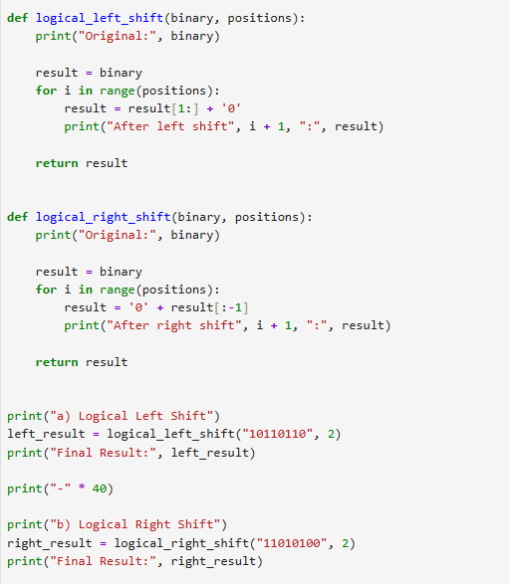

Output
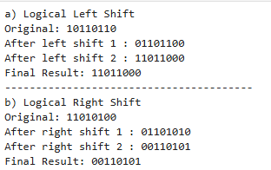

manual binary calculation
a) Logical left shift of 10110110 by 2 positions
Step 1: Shift left by one position and insert 0 at the right.
10110110 → 01101100
Step 2: Shift left again and insert 0 at the right.
01101100 → 11011000
Final result: 11011000

b) Logical right shift of 11010100 by 2 positions
Step 1: Shift right by one position and insert 0 at the left.
11010100 → 01101010
Step 2: Shift right again and insert 0 at the left.
01101010 → 00110101
Final result: 00110101

